**Bike Renting**

Priyam Kumar Singh

19th July 2018

**Contents**

|  |  |
| --- | --- |
| **S.No** | **Content** |
|  |  |
| **1** | Chapter 1 : Introduction |
| **1.1** | Problem Statement |
| **1.2** | Dataset |
|  |  |
| **2** | Chapter 2 : Methodology |
| **2.1** | Pre-processing |
| **2.2.1** | Check for missing values |
| **2.2.2** | Dropped Unnecessary Columns |
| **2.2.3** | Outlier Analysis |
| **2.2.3** | Feature Selection |
| **2.3.1** | Modelling |
| **2.3.2** | Linear Regression |
| **2.3.3** | XGBoost Regressor |
| **2.3.4** | Support Vector Machine |
|  |  |
| **3** | Chapter 3 : Conclusion |
| **3.1** | Model Evaluation |
|  |  |
| **4.1** | Appendix A : Python Code |
| **4.2** | Appendix B : R Code |

**Chapter 1**

Introduction

**1.1 Problem Statement**

The objective of this project is the Predication of bike rental count on daily based on the environmental and seasonal settings.

Bike sharing systems are new generation of traditional bike rentals where whole process from membership, rental and return back has become automatic. Through these systems, user is able to easily rent a bike from a particular position and return back at another position. Currently, there are about over 500 bike-sharing programs around the world which is composed of over 500 thousands bicycles. Today, there exists great interest in these systems due to their important role in traffic, environmental and health issues.

Apart from interesting real world applications of bike sharing systems, the characteristics of data being generated by these systems make them attractive for the research. Opposed to other transport services such as bus or subway, the duration of travel, departure and arrival position is explicitly recorded in these systems. This feature turns bike sharing system into a virtual sensor network that can be used for sensing mobility in the city. Hence, it is expected that most of important events in the city could be detected via monitoring these data.

**1.2 Dataset**

We are provided with a public dataset that has bike renting pattern of users of two consecutive years. We are expected to develop a model to predict the renting trend of the bikes for the next year.

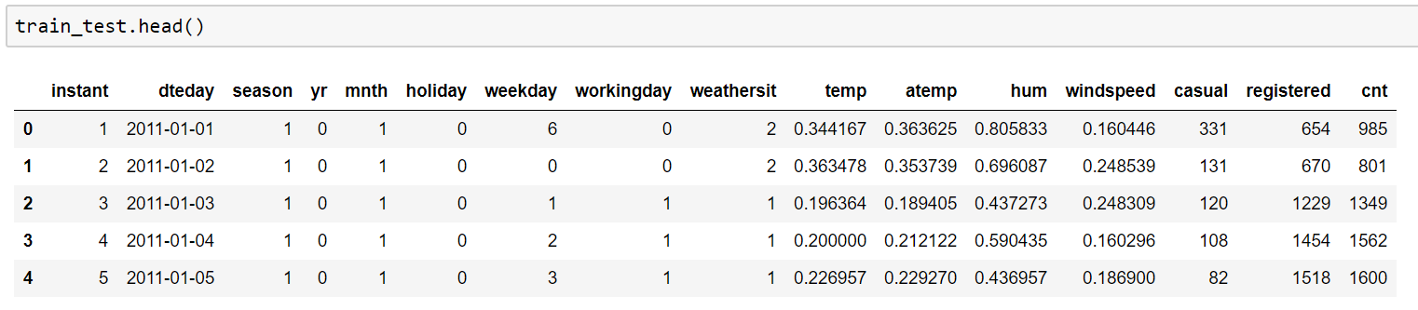(Table 1.1 Following are the first 5 rows of Train dataset)

Following is the list of all variables which will be used in the prediction of bike rents.

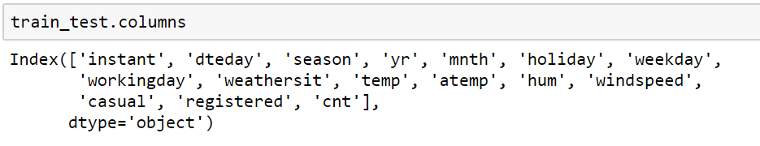

(Figure1.2 List of all variables in Training dataset)

**Chapter 2**

Methodology

**2.1 Pre Processing**

Any predictive modelling requires that we should look at the data first which we will be going to use to train the model because if the data used will be uncleaned and unstructured then it will not produce good results which may lead to our prediction failure.

We checked for the missing missing values, dropped unnecessary columns which was not going to add any predictive significance to our model.

**2.1.1 Check for missing values**

This is a necessary step to be performed before we start our project as it also creates problem later. First of all check how much data is missing as in my case there are no filed missing in comment text so we will go with next step.

**2.1.2 Dropped Unnecessary Columns**

We have dropped unnecessary columns which was not going to add any predictive significance to our model. Instant and dteday columns are removed from the dataset as it was of no use to the model.

**2.1.3 Outlier Analysis**

Outliers are extreme values that deviate from other observations on data , they may indicate a variability in a measurement, experimental errors or a novelty. In other words, an outlier is an observation that diverges from an overall pattern on a sample.

We have used boxplot for viewing the outliers present in the data. Most of the outliers were present in the windspeed column.

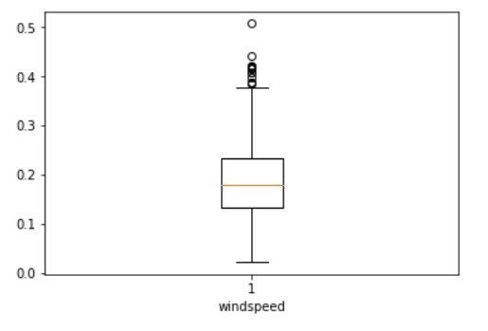

Figure 2.1 : Outliers in a windspeed column

These outliers replaced with null values. By performing missing value analysis these null values are imputed using mean strategy or most frequent number strategy.

**2.1.4 Feature Selection**

Before performing any type of modeling we need to assess the importance of each predictor variable in our analysis. There is a possibility that many variables in our analysis are not important at all to the problem of class prediction. We have used heatmap, pearson test, anova in python for feature selection and corrplot in R.

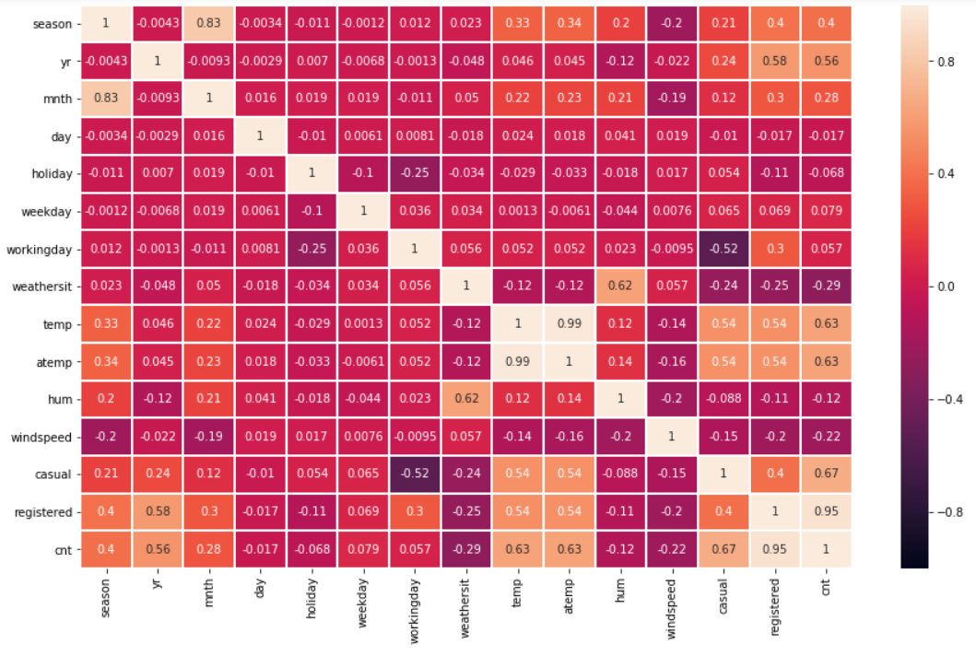

Fig. heatmap of variables

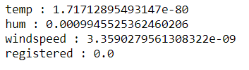 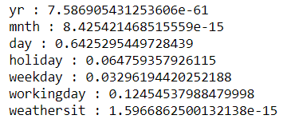

Fig. p-values of all variables after pearson test(left) and anova test(right)

Based on the p-values, column’s significance can be understood and hence those columns are dropped whose p-value was less than 0.05.

**2.3 Modeling**

**2.3.1 Model Selection**

Model selection is the process of choosing between different machine learning approaches - e.g. SVM, linear regression, etc - or choosing between different hyperparameters or sets of features for the same machine learning approach - e.g. deciding between the polynomial degrees/complexities for linear regression.

The choice of the actual machine learning algorithm (e.g. SVM or Xgboost regressor) is less important than you'd think - there may be a "best" algorithm for a particular problem, but often its performance is not much better than other well-performing approaches for that problem.

There may be certain qualities you look for in an model:

* Interpretable
* Simple - easy to explain and understand
* Accurate
* Fast (to train and test)
* Scalable

**2.3.2 Linear Regression**

Simple linear regression is useful for finding relationship between two continuous variables. One is predictor or independent variable and other is response or dependent variable. It looks for statistical relationship but not deterministic relationship. Relationship between two variables is said to be deterministic if one variable can be accurately expressed by the other. For example, using temperature in degree Celsius it is possible to accurately predict Fahrenheit. Statistical relationship is not accurate in determining relationship between two variables. For example, relationship between height and weight.

The core idea is to obtain a line that best fits the data. The best fit line is the one for which total prediction error (all data points) are as small as possible.

Y(pred) = b0 + b1*x

The values b0 and b1 must be chosen so that they minimize the error. If sum of squared error is taken as a metric to evaluate the model, then goal to obtain a line that best reduces the error.

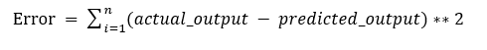

If we don’t square the error, then positive and negative point will cancel out each other.

For model with one predictor, Intercept Calculation is done using,

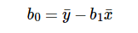

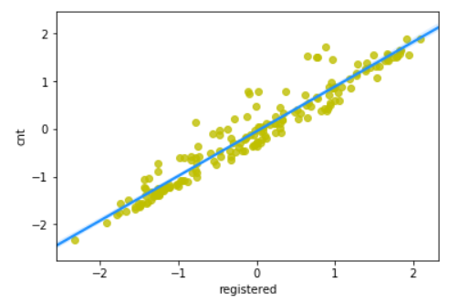

Fig : Linear regression performed on registered and cnt(response) column.

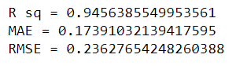

Fig. R-sq, Mean square error, Root mean square error achieved by linear regression

**2.3.3 XGBoost Regressor**

XGBoost stands for eXtreme Gradient Boosting.XGBoost is an algorithm that has recently been dominating applied machine learning and Kaggle competitions for structured or tabular data.

XGBoost is an implementation of gradient boosted decision trees designed for speed and performance.This algorithm goes by lots of different names such as gradient boosting, multiple additive regression trees, stochastic gradient boosting or gradient boosting machines.

Boosting is an ensemble technique where new models are added to correct the errors made by existing models. Models are added sequentially until no further improvements can be made.

By using this model, we have plotted the feature importance graph.

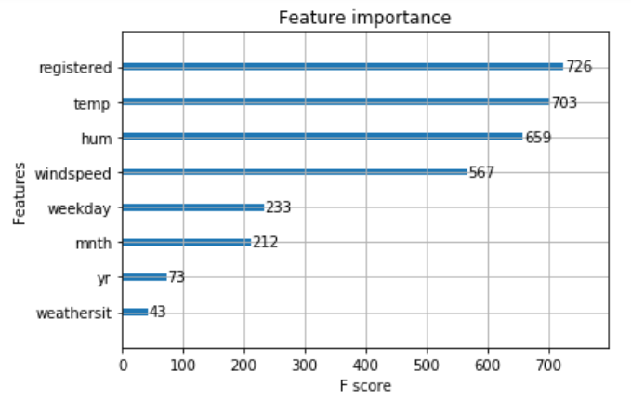

Fig. Feature importance graph using XGBoost.

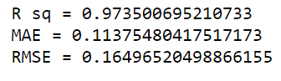

Fig. Score Achieved by XGBoost Regressor with default parameters.

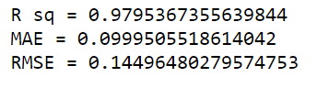

Fig. Score Achieved by XGBoost Regressor with tuned parameters.

**2.3.4 Support Vector Machine**

Support vector machine (SVM) analysis is a popular machine learning tool for classification and regression. It is formally defined by separating hyperplane. In other words, given labeled training data (supervised learning), the algorithm outputs an optimal hyperplane which categorizes new examples. In two dimentional space this hyperplane is a line dividing a plane in two parts where in each class lay in either side.

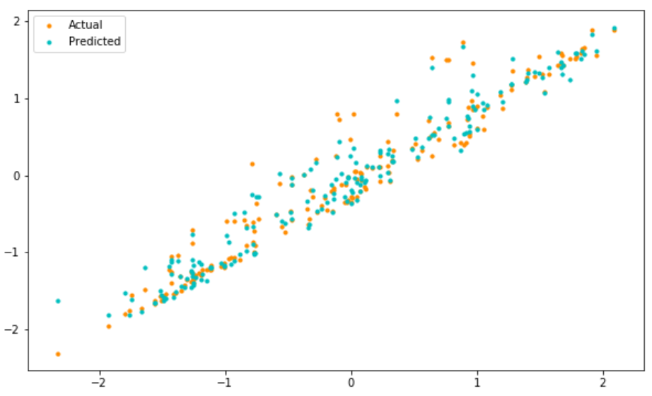

Fig. Actual and Predicted values from SVM model

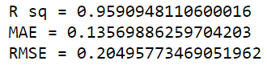

Fig. Score Achieved by SVM with default parameters.

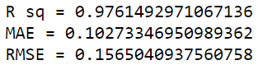

Fig. Score Achieved by SVM with tuned parameters.

**Chapter 3**

Conclusion

**3.1 Model Evaluation**

Using sklearn library in python and MLmetrics in R, we have calculated the R-square, Mean absolute error, Root mean square error of our model. Higher the value of r square, better is the model. And lower the value of MAE and RMSE, better is the model. MAE and RMSE denotes error. So, their small values are desirable.

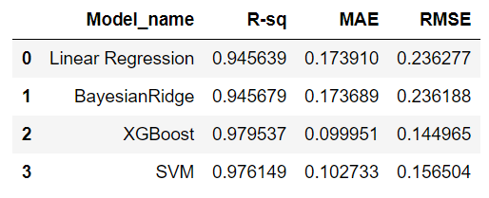

Fig. Models Summary (Python)

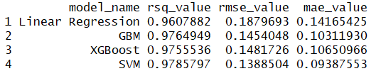

Fig. Models Summary (R)

**Appendix A - Python Code**

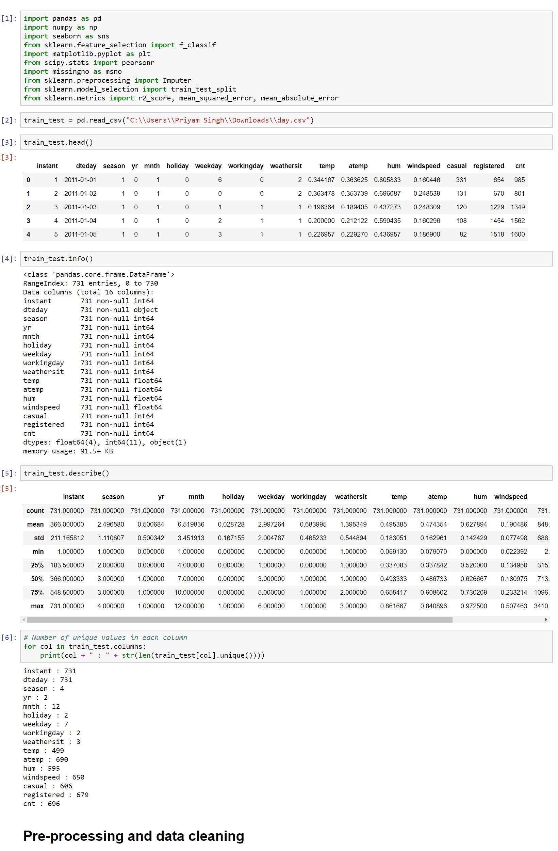

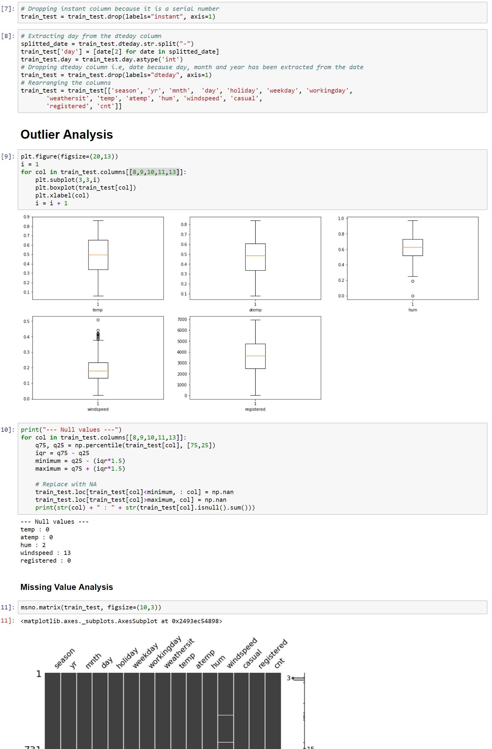

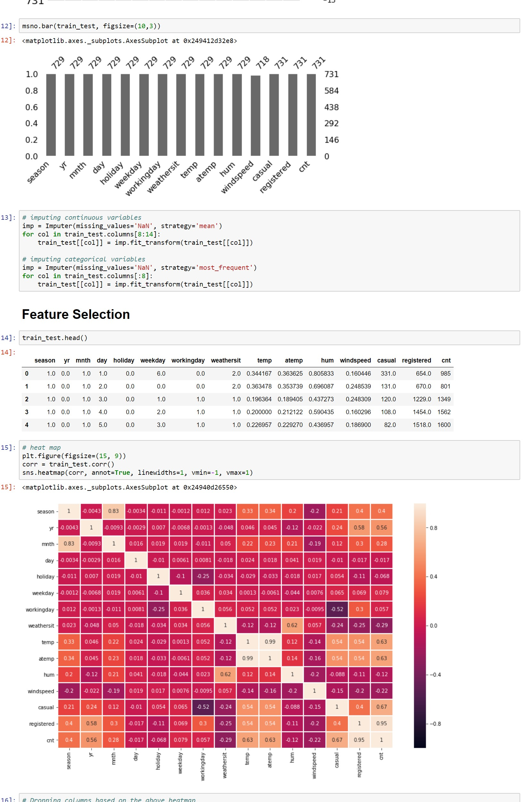

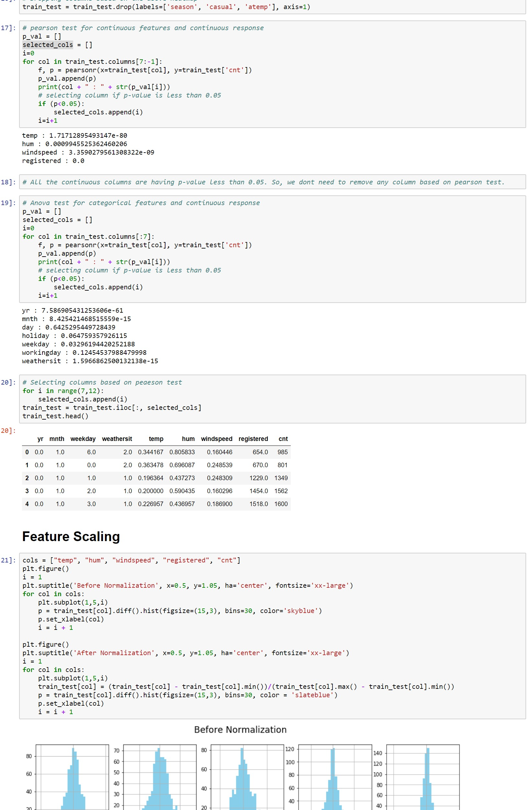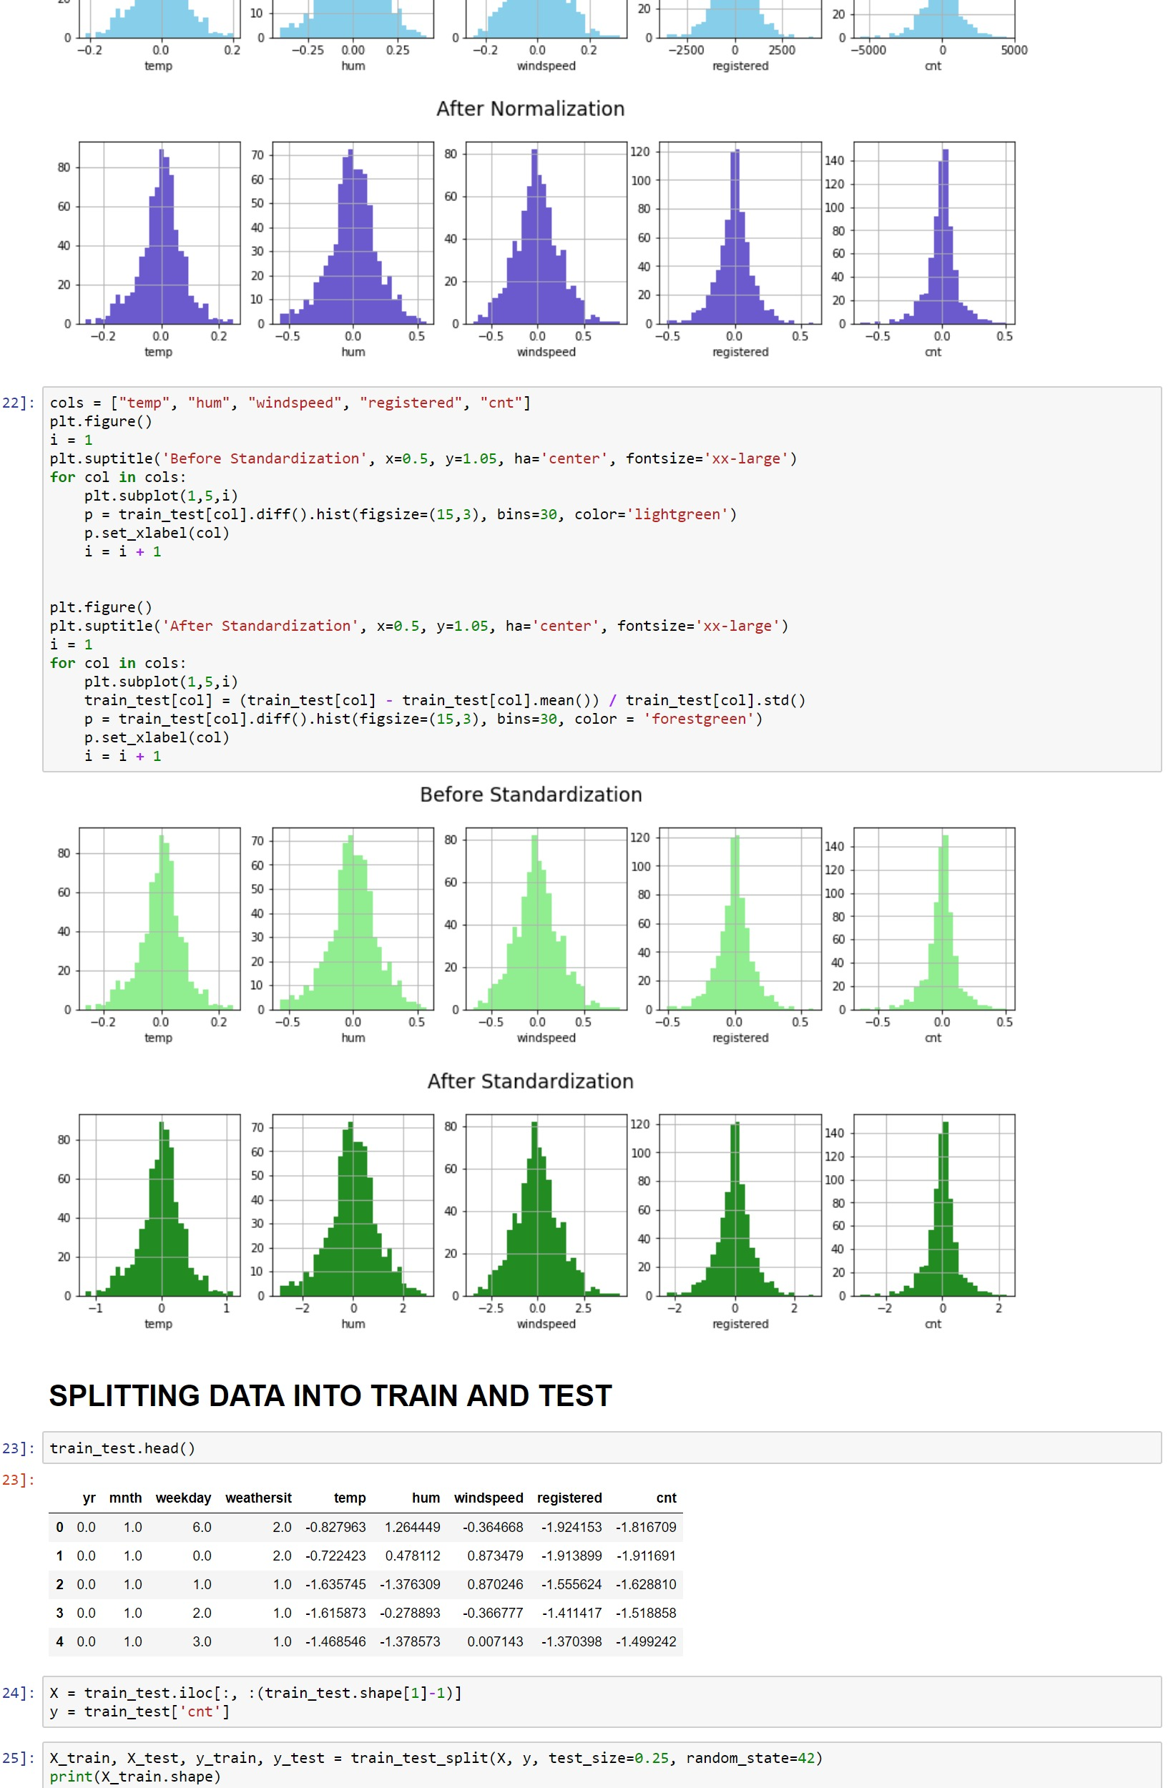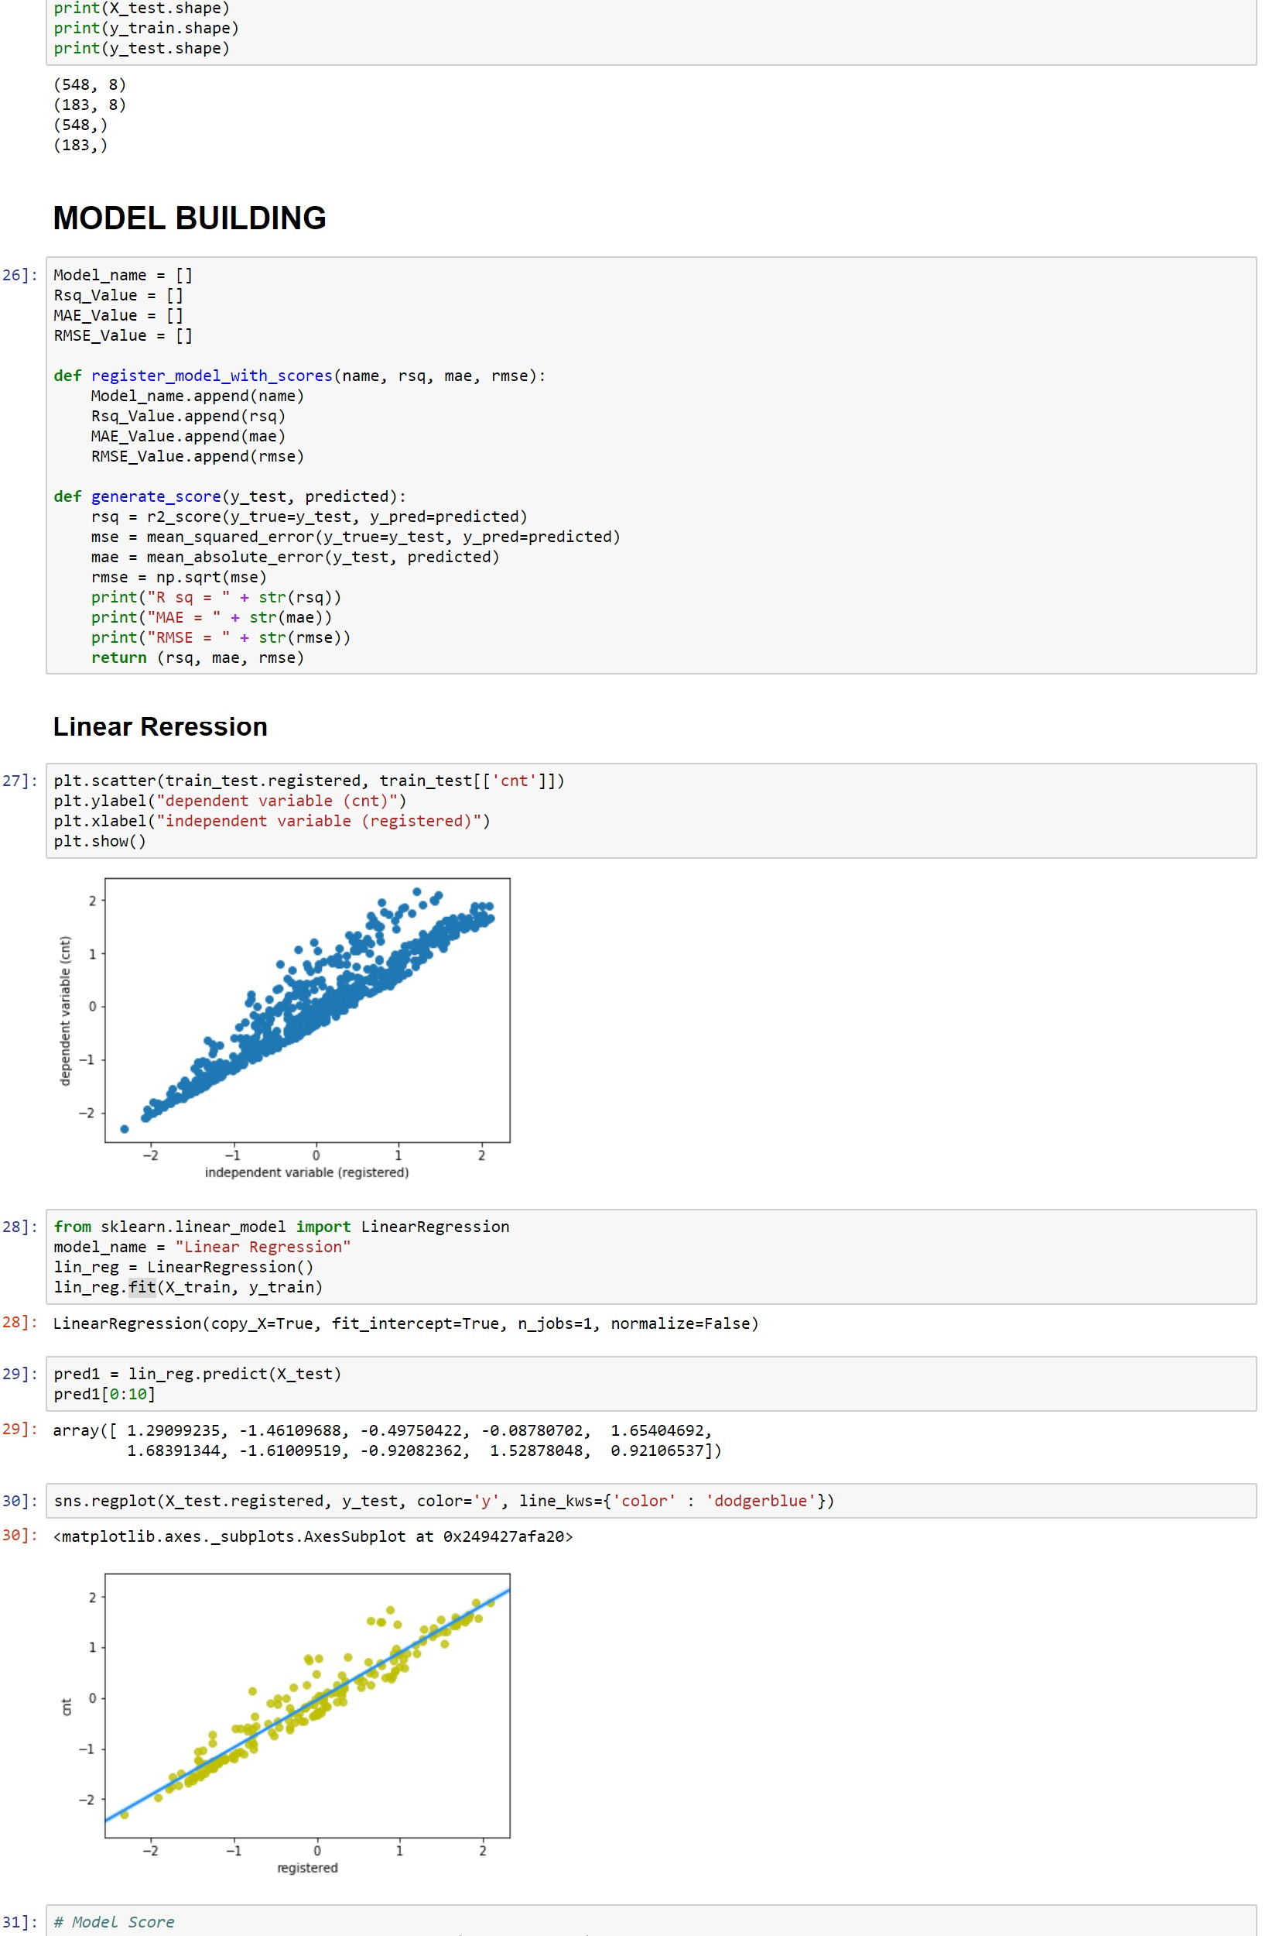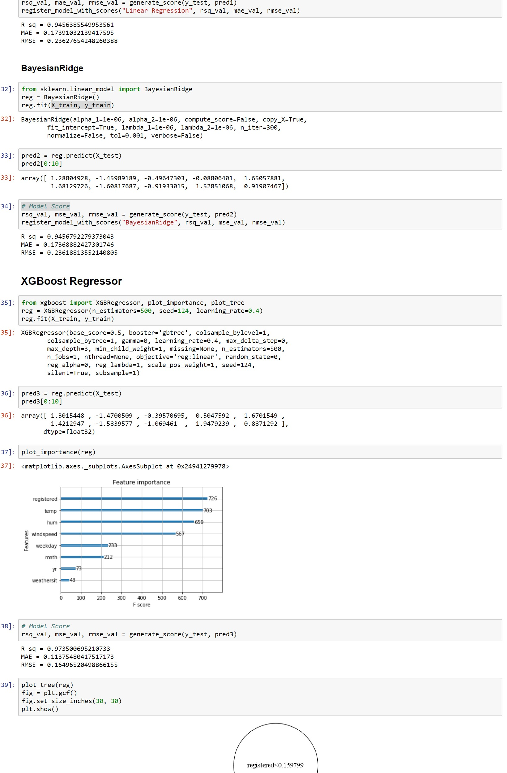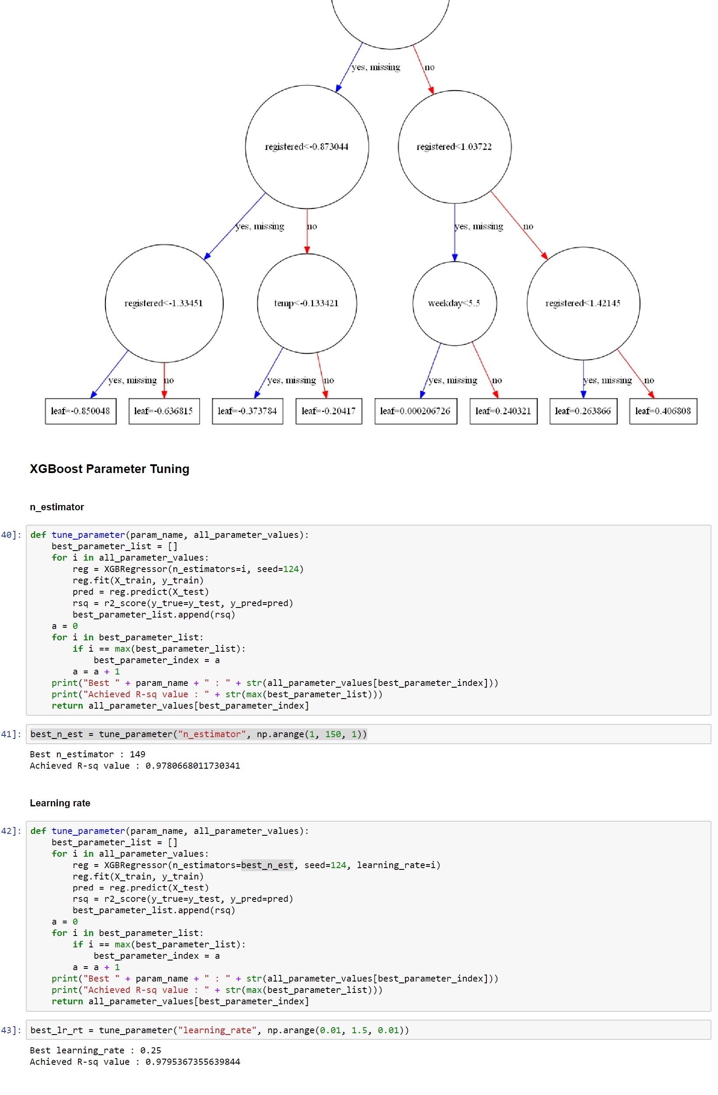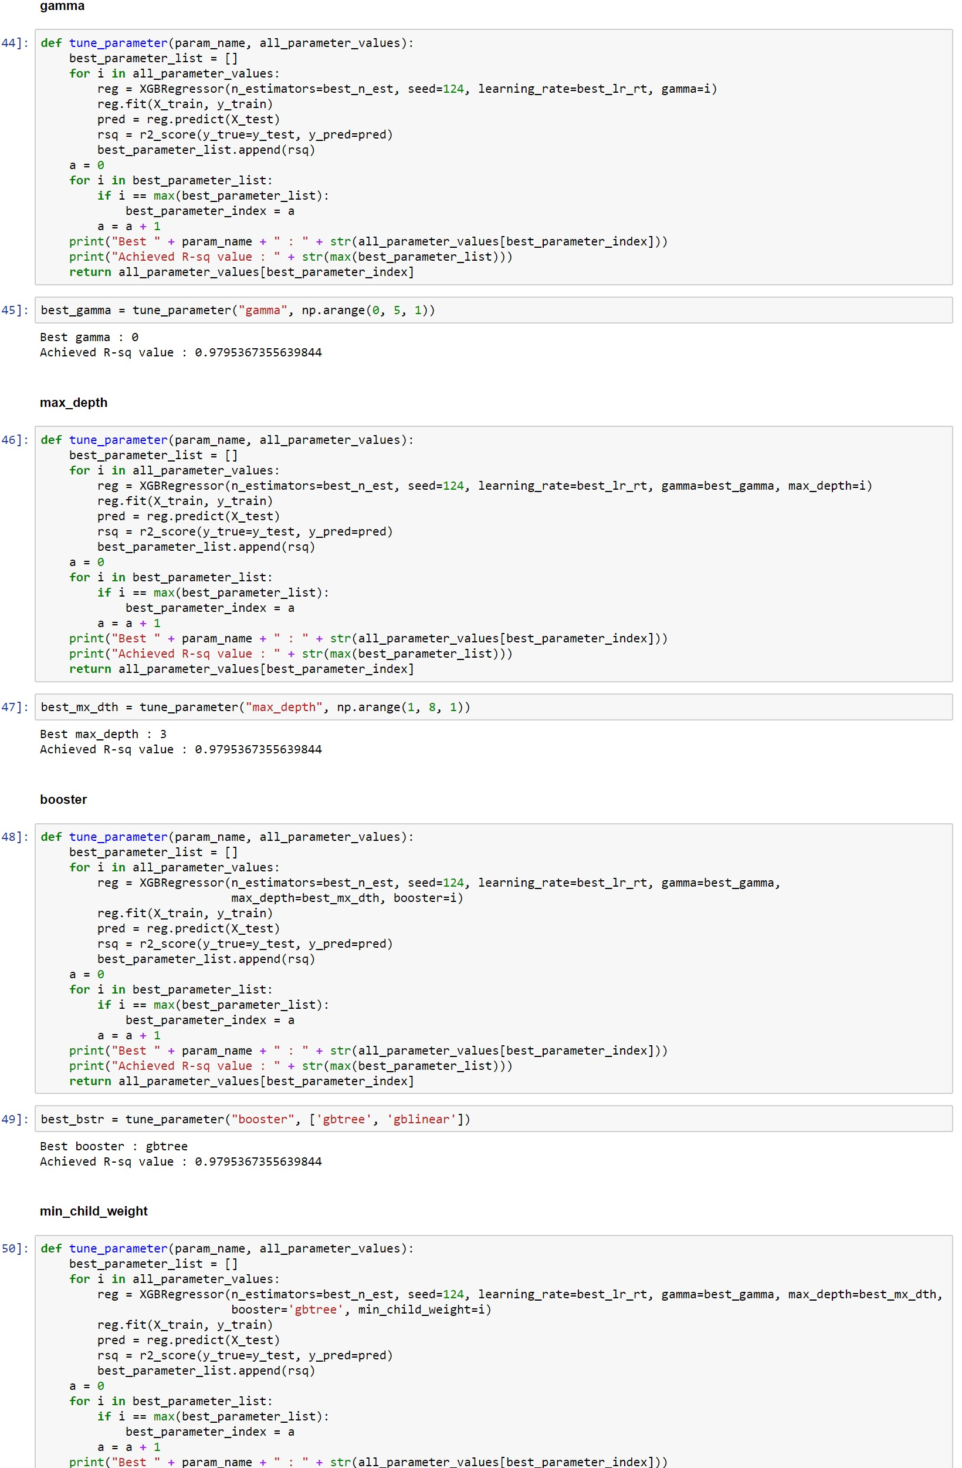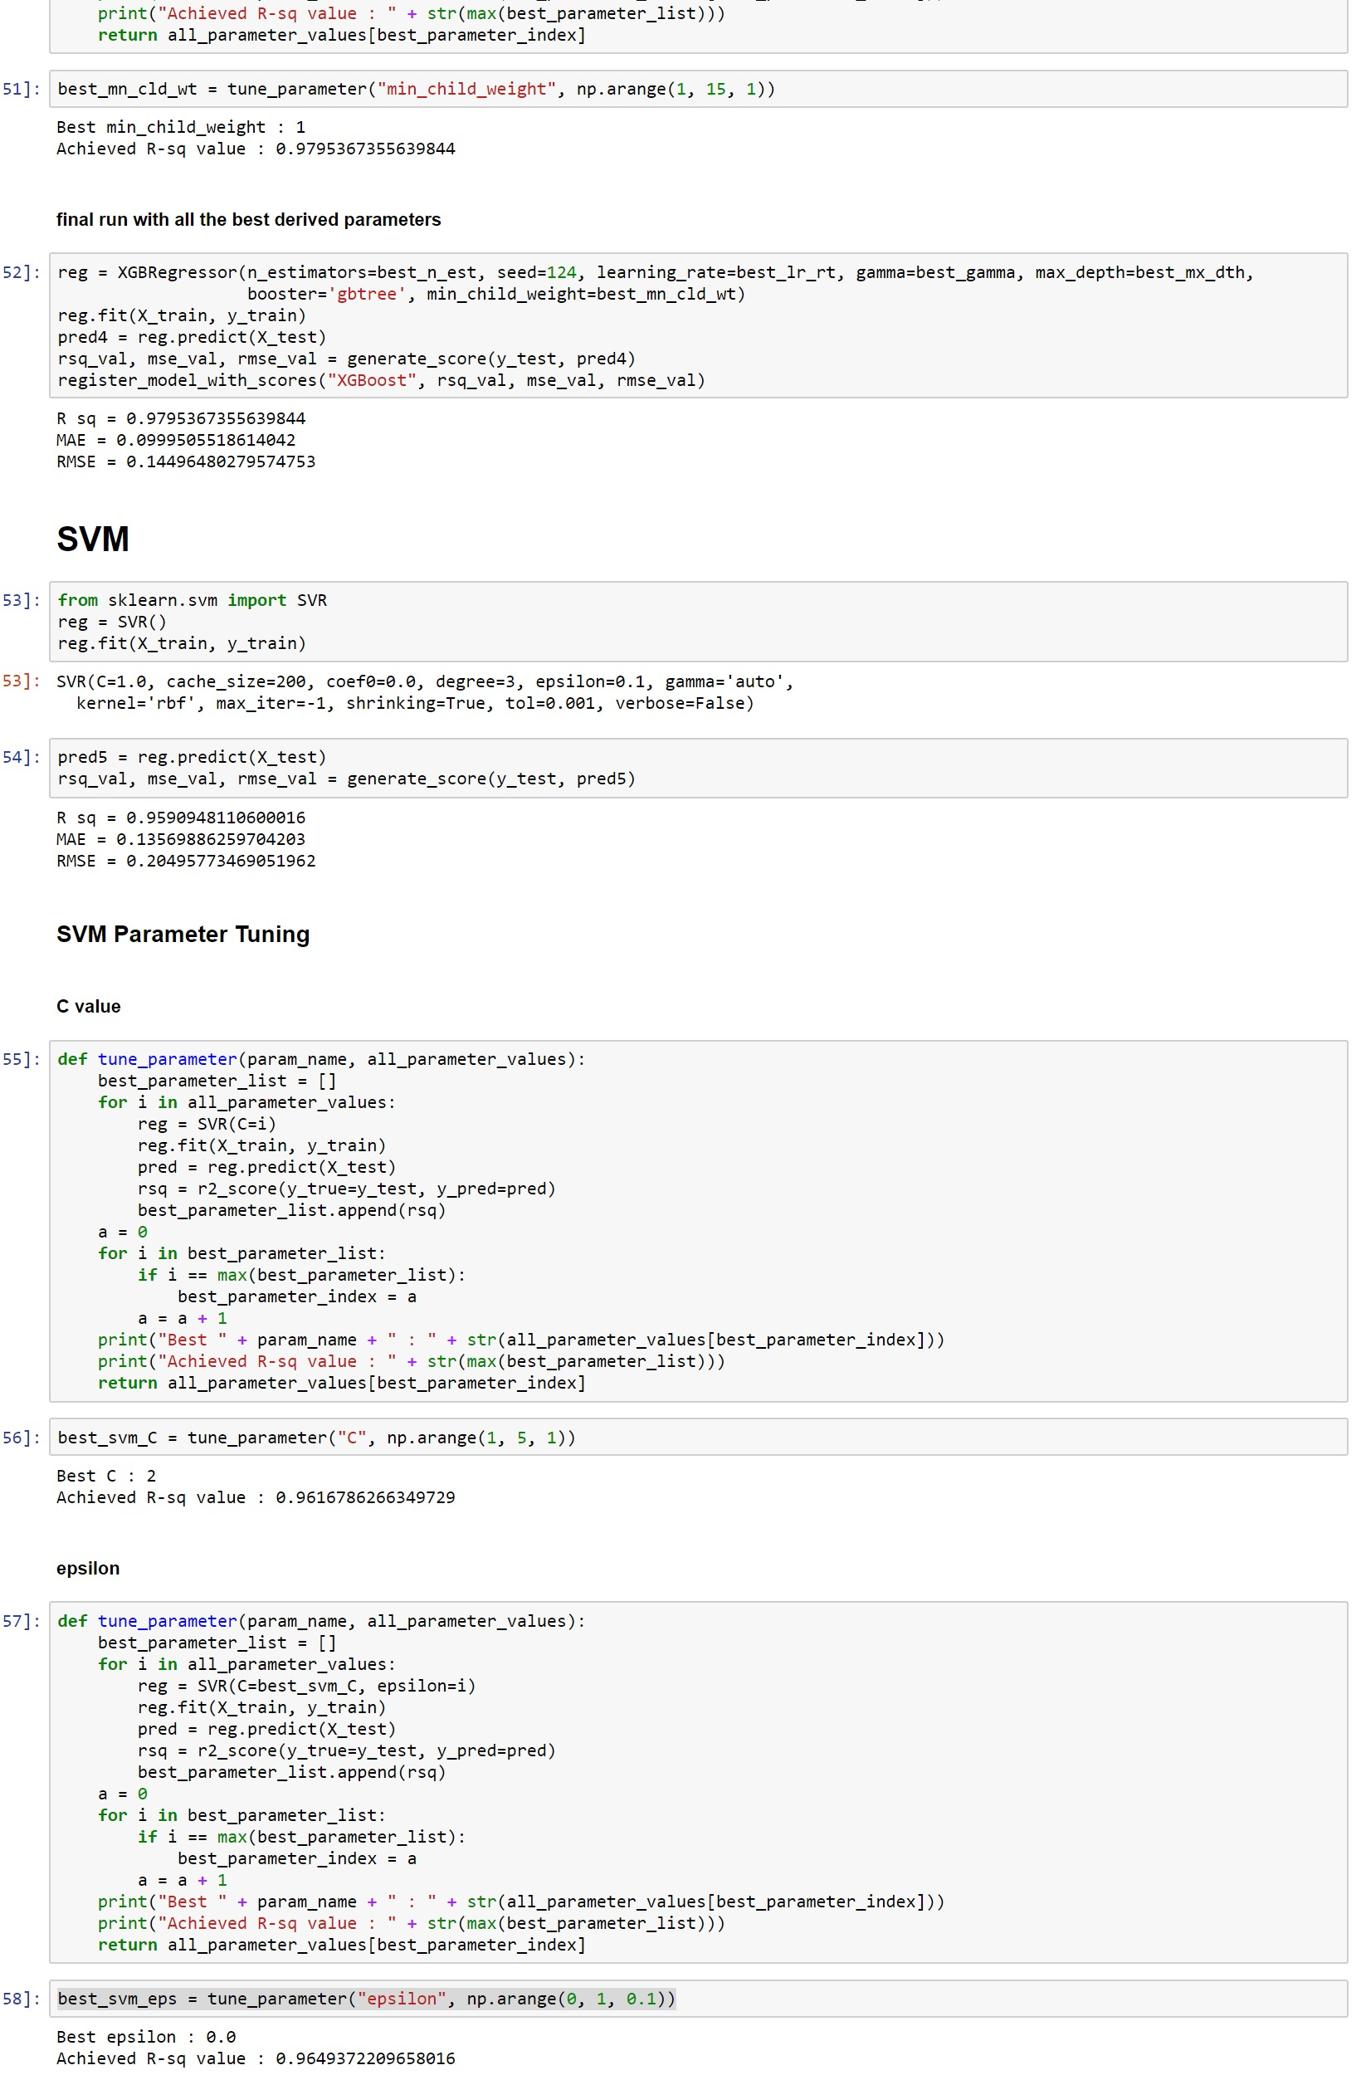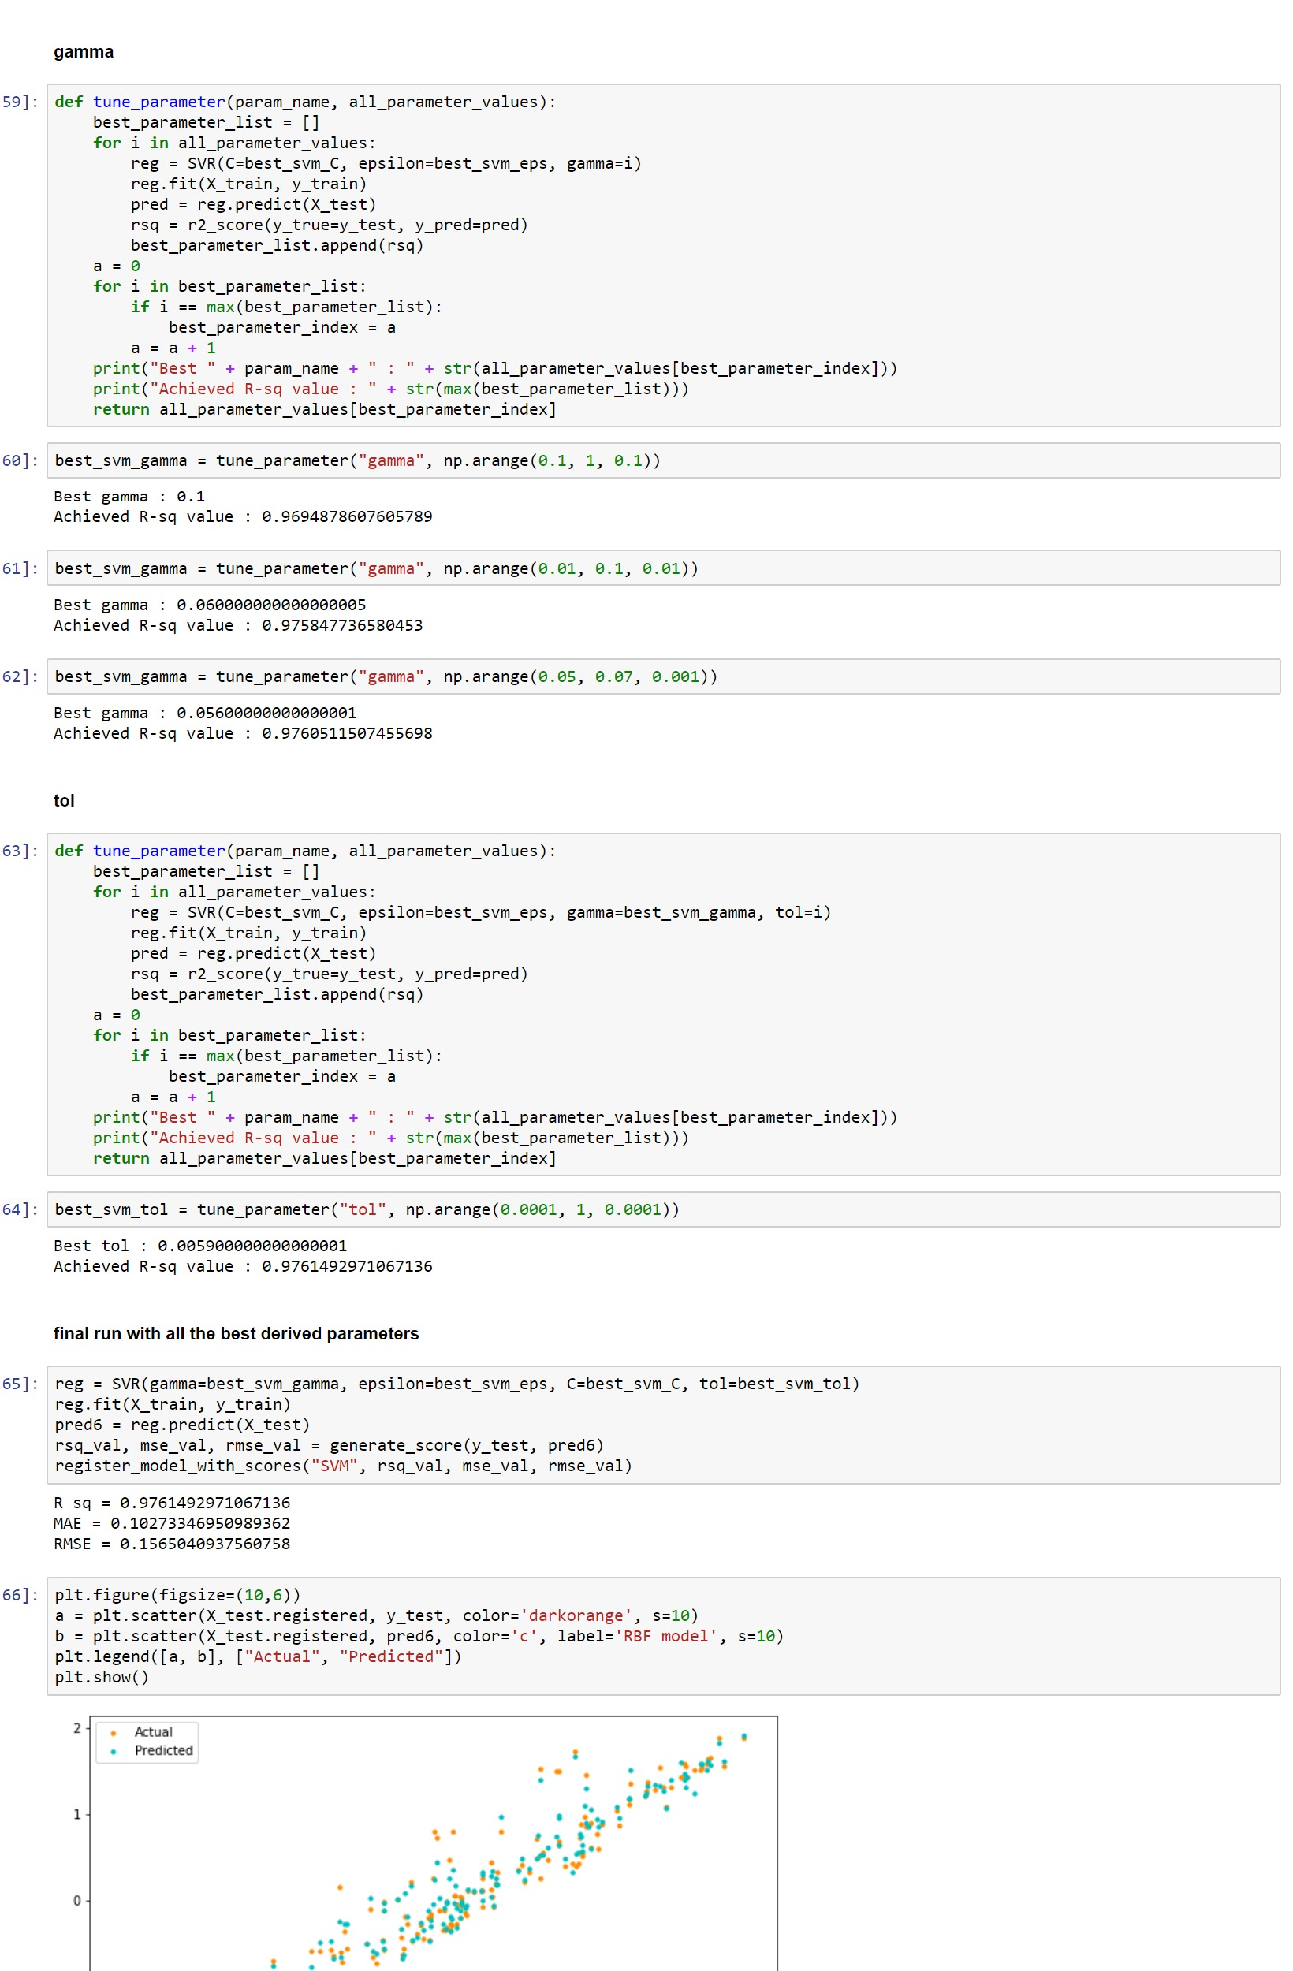

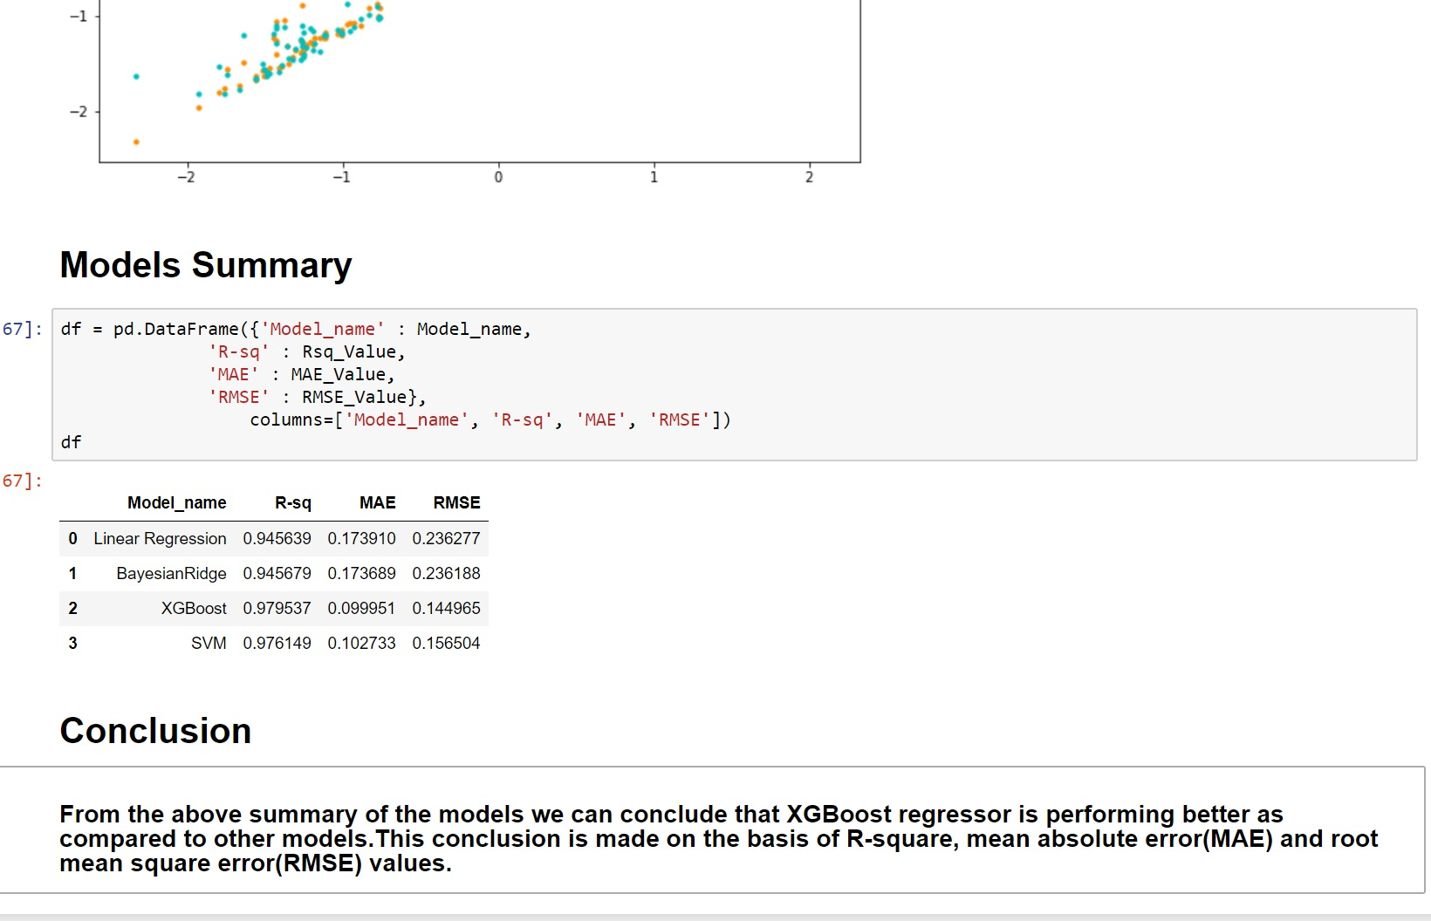

**Appendix B - R Code**

